

**EEEN 210**

**COMPUTER GRAPHICS**

# Mausoleum of Halicarnassus in 3D

## BY

Tuğberk GÖÇ

**SUPERVISED**

## BY

### Zeynep AYAZ

**ISTANBUL BILGI UNIVERSITY**

**FALL 2018**

## TABLE OF CONTENTS

1. INTRODUCTION…………………………………………………4
2. BOTTOM………………………………….................................... 4
3. BEFORE STARTING 3D…………………………………………4
4. BEFORE COLUMNS..……………………………………………5
5. BEFORE STARTING ROOF..…………………………………....6

6. ROOF……………………………………………………………...7

### 6.1. STARTING ROOF……………………………………………...7

### 6.2 FINISH WORK FOR ROOF………………………..…………..8

7. CONCLUSION……………………………………...……………14

## LIST OF FIGURES

Fig 1. Bottom 2D…………………………………………………………4

Fig 2. South and West Sides……………………………………...………5

Fig 3. Basement………………………………………....………..………6

Fig 4. Columns………………………………………………………..….7

Fig 5. Roof 2D…………………………………………….……………...8

Fig 6. Roof 3D……………………………………………………………8

Fig 7. ?………………………………………………………..11

Fig 8. ?…………………………………………………….12 Fig 9. ?…………………………………….…………….13

**1. INTRODUCTION**

In this report, I will cover all the details, when I have experienced doing final project which is drawing Mausoleum of Halicarnassus in 3D. Before doing that, I will want to share what I use, when I have done the project. I used west and south sides of Halicarnassus in 2D that we have done in midterm project. Also, I draw in Autocad application. Comparing to midterm, I used 3D modelling instead of drafting & annotation mode.

**2. BOTTOM**

At the beginning. I tried to understand the concept of Halicarnassus in 3D, then I figured out where I should start. Firstly, I need to append west and south parts that I have done in midterm project. In detail files, I draw the bottom as 2D to extrude. As you seen figure 1 at below.

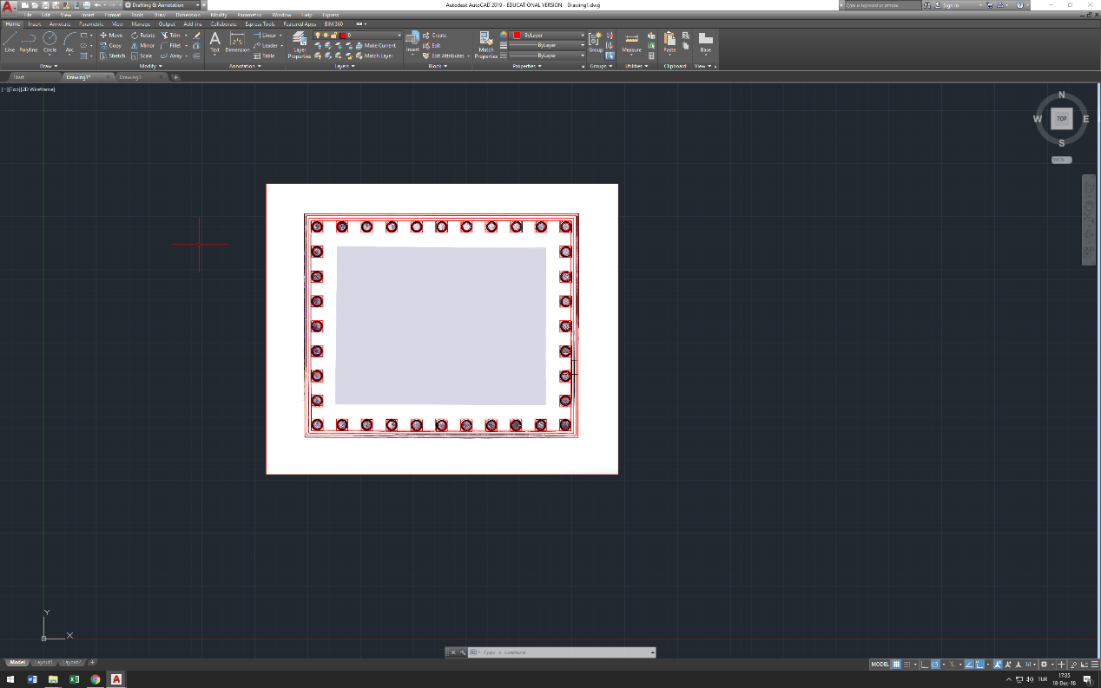

**.** Figure 1 : Bottom 2D

When I finish this work, I am going to start with new draft to continue initial part. This project will be my final project. It is going to cover everything else end of the project.

**3. BEFORE STARTING 3D**

Secondly, I take west and south. Creates a new draft. Copy and place them as 90 degrees in 3D. Also, I choose 3D Model to continue work. Now, I need to put the bottom between them, then start to extrude walls. For doing that, my basement is going to be completed. In the same way, I record the every distances to my notes because I could need them end of the project, when I want to change something about basement.

Also, I measure circle which I put the column. Then, I started to draw columns which using my 2D column. In this time, I though that I need to turn of 2D shapes, when I need it. Thus, I realized it, I put all the shapes just one layer. I change them for west to the west red layer, also others the same. For doing that, I can continue work and also I can turn them off. Therefore, I can increase my computer performance and my work. I reference one of the side. Then, continue to work Halicarnassus. Also, I haven’t done the middle wall because of columns. When I finished to do columns, I put them on to the basement, then I made the main wall with referencing column height.

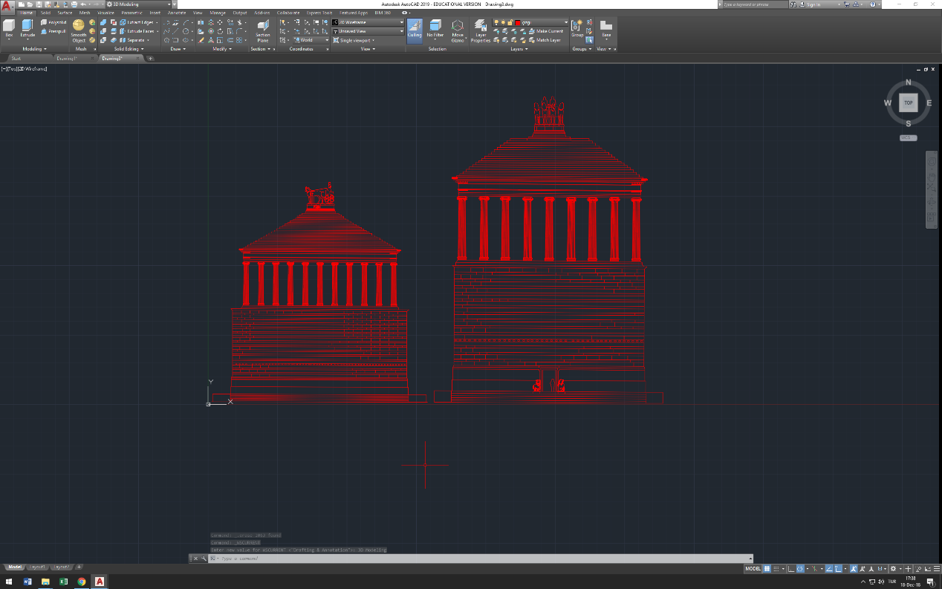

**.** Figure 2 : South and West Sides

In the next page, you can see finish work from here.

**4. BEFORE COLUMNS**

As you can see below figure, I finished to extrude basement walls. Then, I started doing columns with using my 2D column. I extrude the column, then I tried to make similar with the detail column photo. For that reason, I realized that, at the beginning, I need to make a good bottom shape which is not just a circle. I draw a good shape bottom for that. Also I need to increase height. Before doing that, I made a reference bigger than my circle. Thus, I copied to what I draw. Put into the upside. Then, append them with using lines. At the end, I had the column basement. Now, I need to do the upper part. I took my reference 2D, then extrude it. Put it on to the column. My column is ready.

I count to how many columns I need. Then, copy them as the number of my counter. Starting to put them on to the basement that I did in the third section.

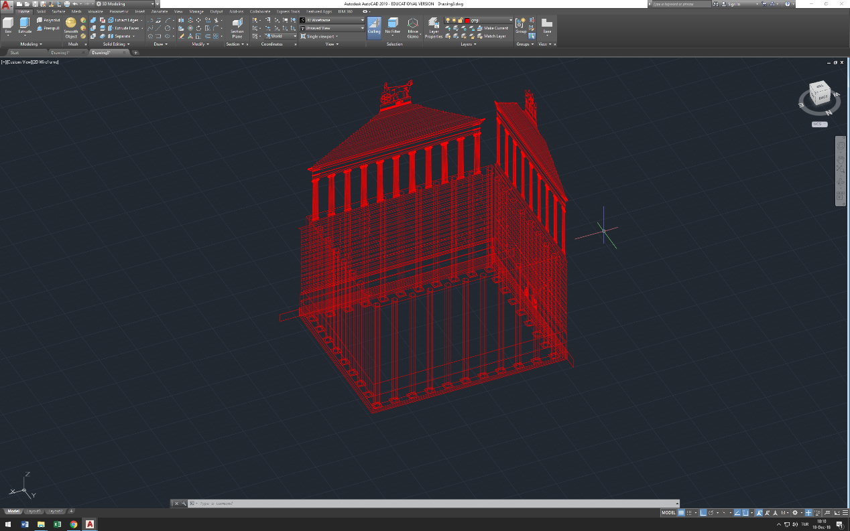

**.** Figure 3 : Basement

In the next page, you can see finish work.

**5. BEFORE STARTING ROOF**

I put the columns to the basement. Now, I need to extrude the main wall to the end of the column. Thus, I used to distance that I took before I draw the column. I have done the main wall. For me, hardest part is going to be start. Because it is really hard to put rectangular 3D shape up to the column and main wall. I tried a lot but not succeed. Because it is really hard to see which point I need to put. In that situation, I found out that I look up project with different sides in terms of back, front, west and east. Therefore, I can set my rectangular object exactly up to the these columns and main object. I continue work as like that.

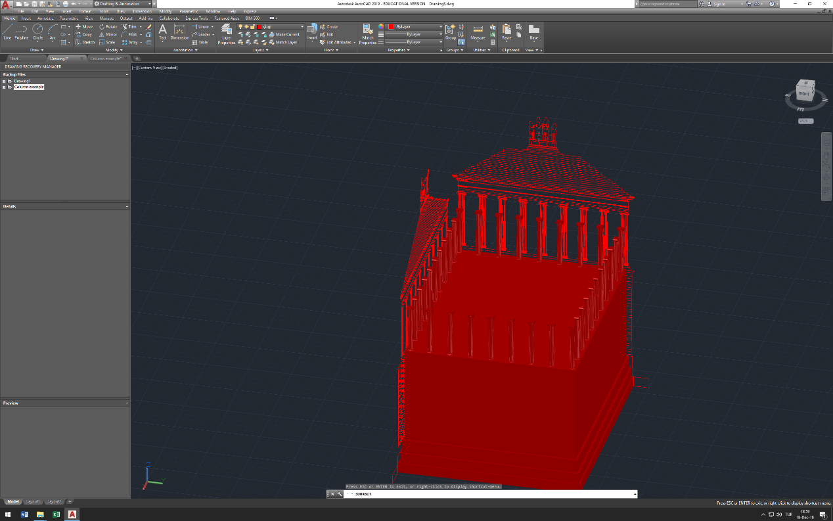

**.** Figure 4 : Columns

In the next page, you can see finish work.

**6. ROOF**

In this part, I am going to do roof basement. Also in this part, I will use my reference distances that I took. Also, I haven’t taken exactly roof details files because it is not convenient comparing my references. That’s why, I used for the first outer rectangular with using my reference, then I decrease the distance stage by stage. By doing that, I will have a good top shape of my building.

**6.1. Starting Roof**

There are two figures in this part. First one is going to show the basement of the roof. (Figure 5) As you seen next page, It is created by using my references. Also, it looks like detail roof file references.

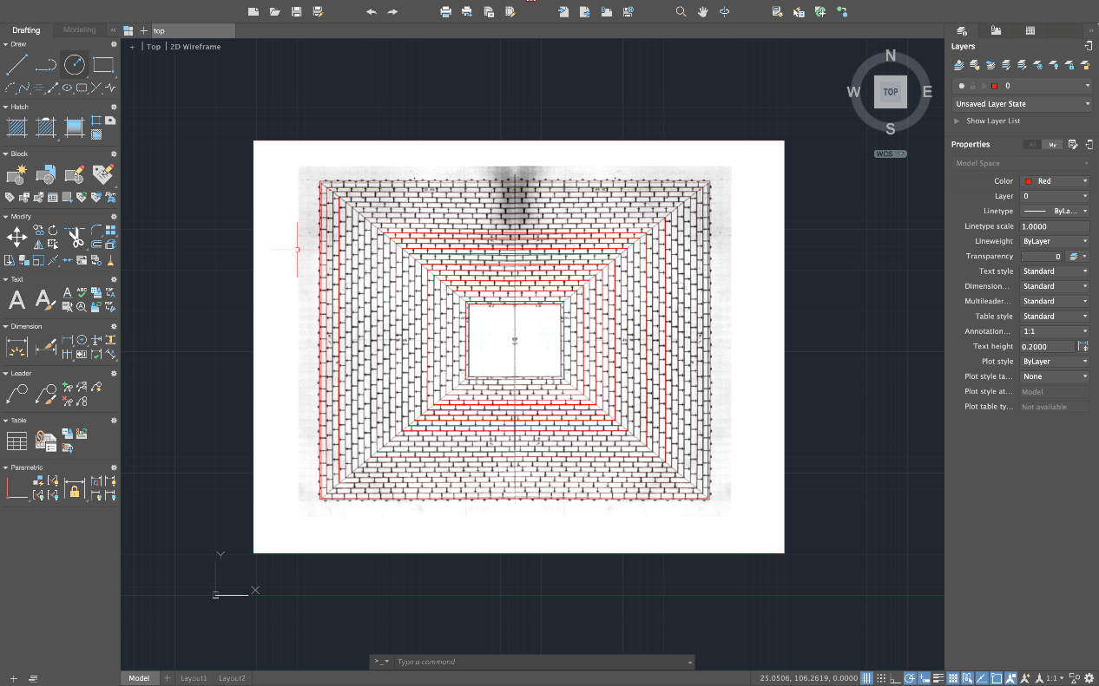

**.** Figure 5 : Roof 2D

**6.2. Finish Work for Roof**

In this section, as you seen below, I finished to do roof. Then, I try to improve myself to do some shapes with using in Autocad 3D shapes. And I want it to show you because it looks awesome from my perspective. But, end of the project, I will change them as to the real one that looks like a horse on to the roof.

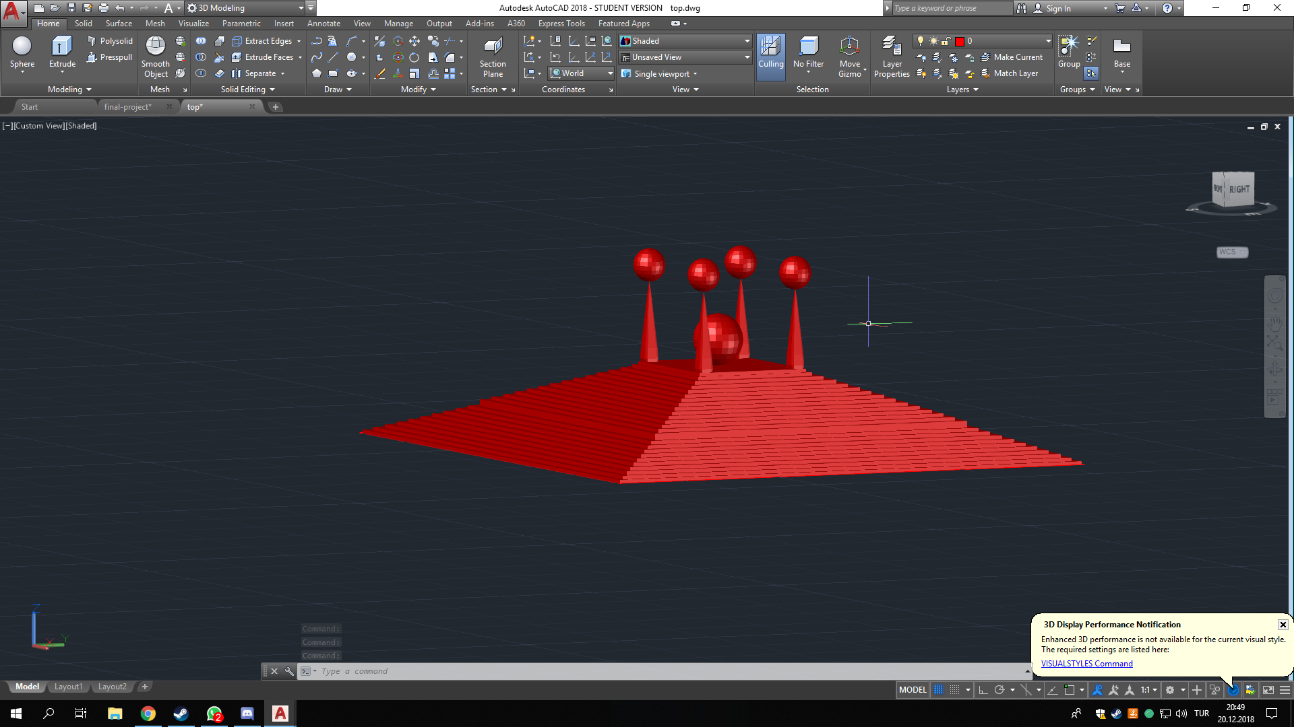

**.** Figure 6 : Roof 3D